AI ASSISTANT CODING
ASSIGNMENT-5
Name: Thrishala Jakkaraju
Hallticket:2303A51514
Batch:22

Task Description #1 (Transparency in Algorithm Optimization)
Task: Use AI to generate two solutions for checking prime
numbers:
• Naive approach(basic)
• Optimized approach
Prompt:
“Generate Python code for two prime-checking methods and
explain how the optimized version improves performance.”
Expected Output:
• Code for both methods.
• Transparent explanation of time complexity.
• Comparison highlighting efficiency improvements.
Code:
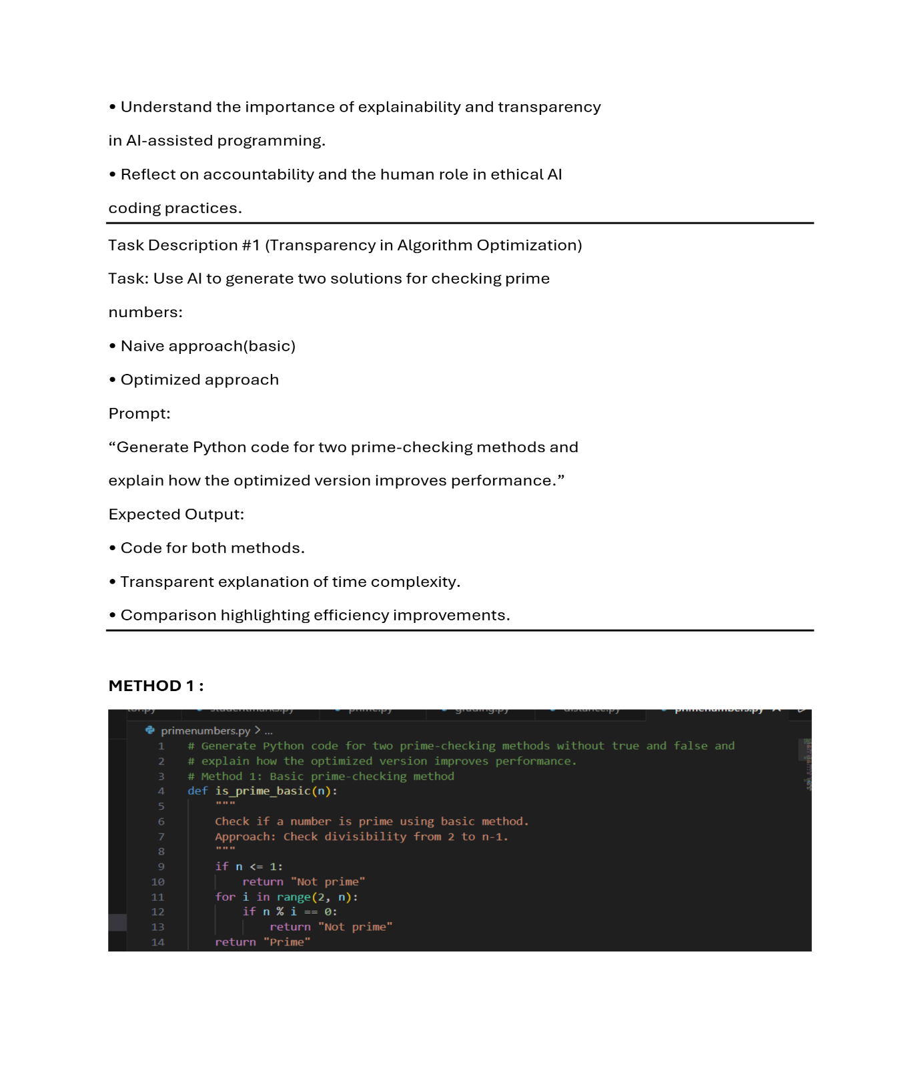
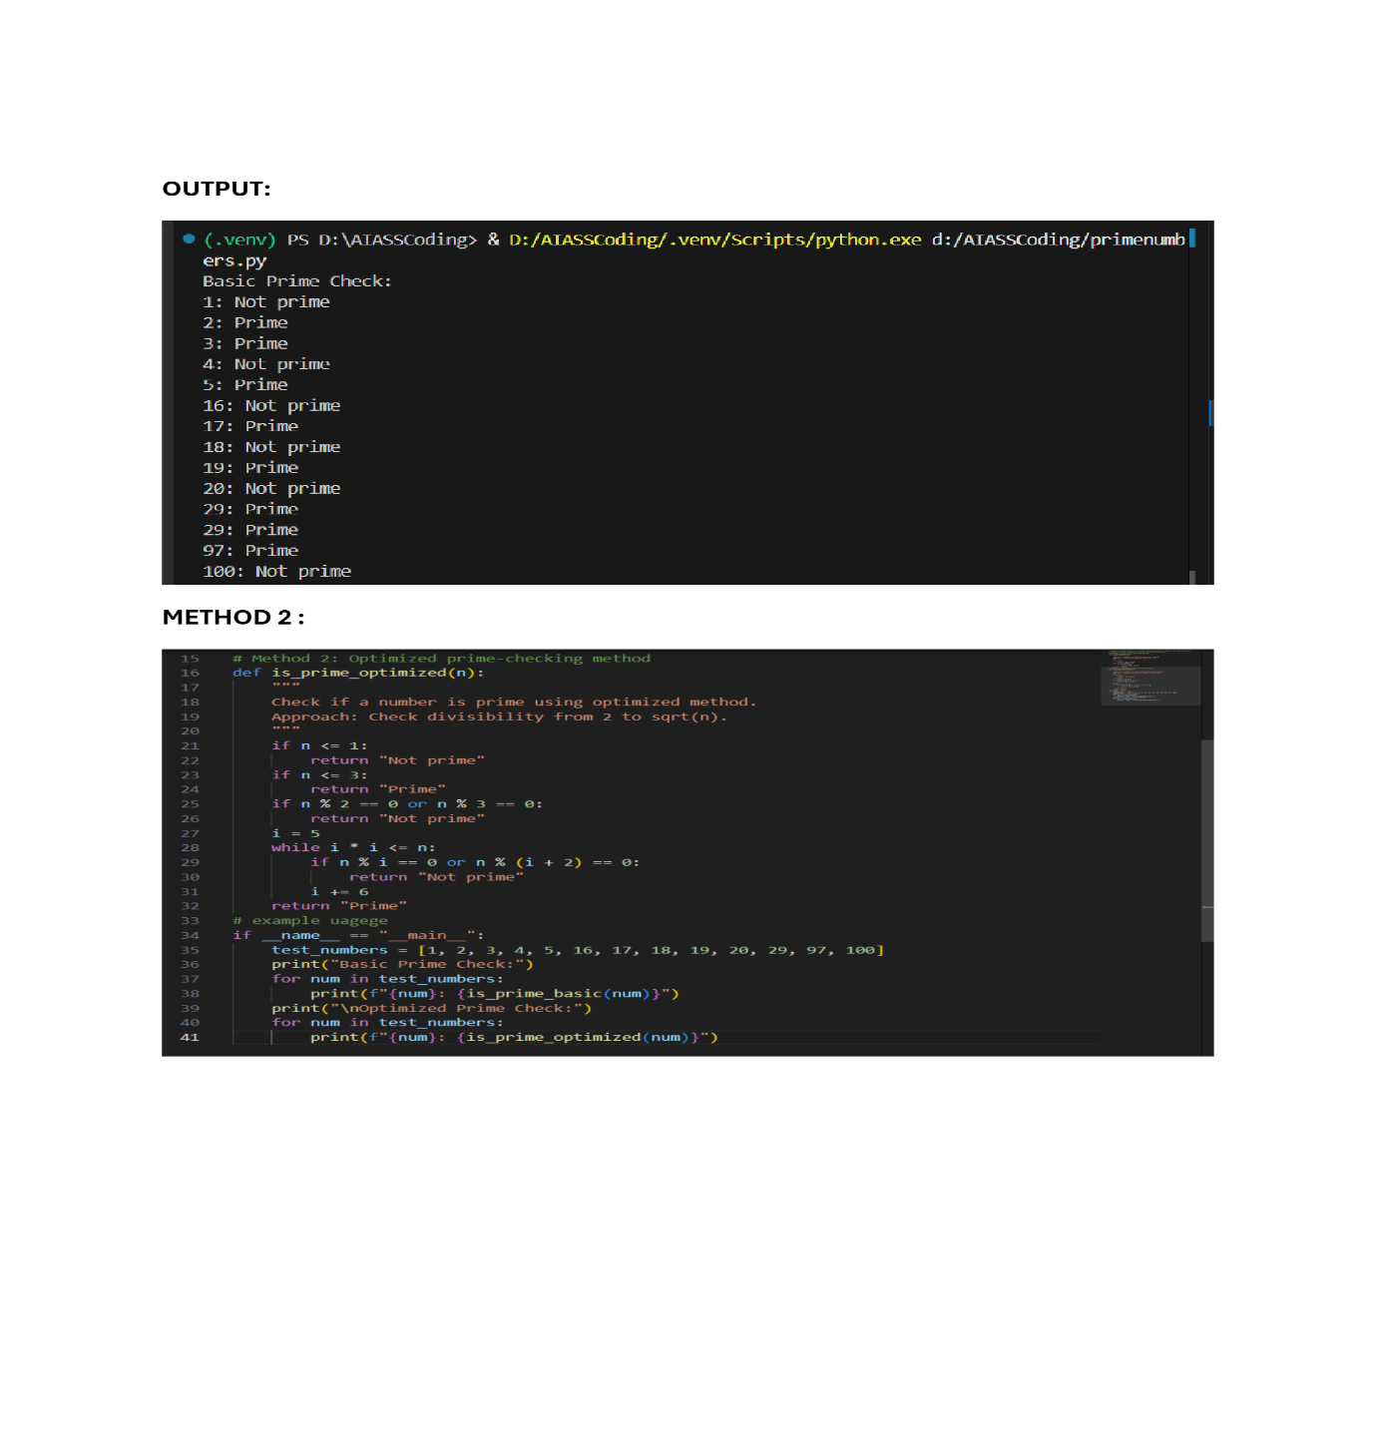
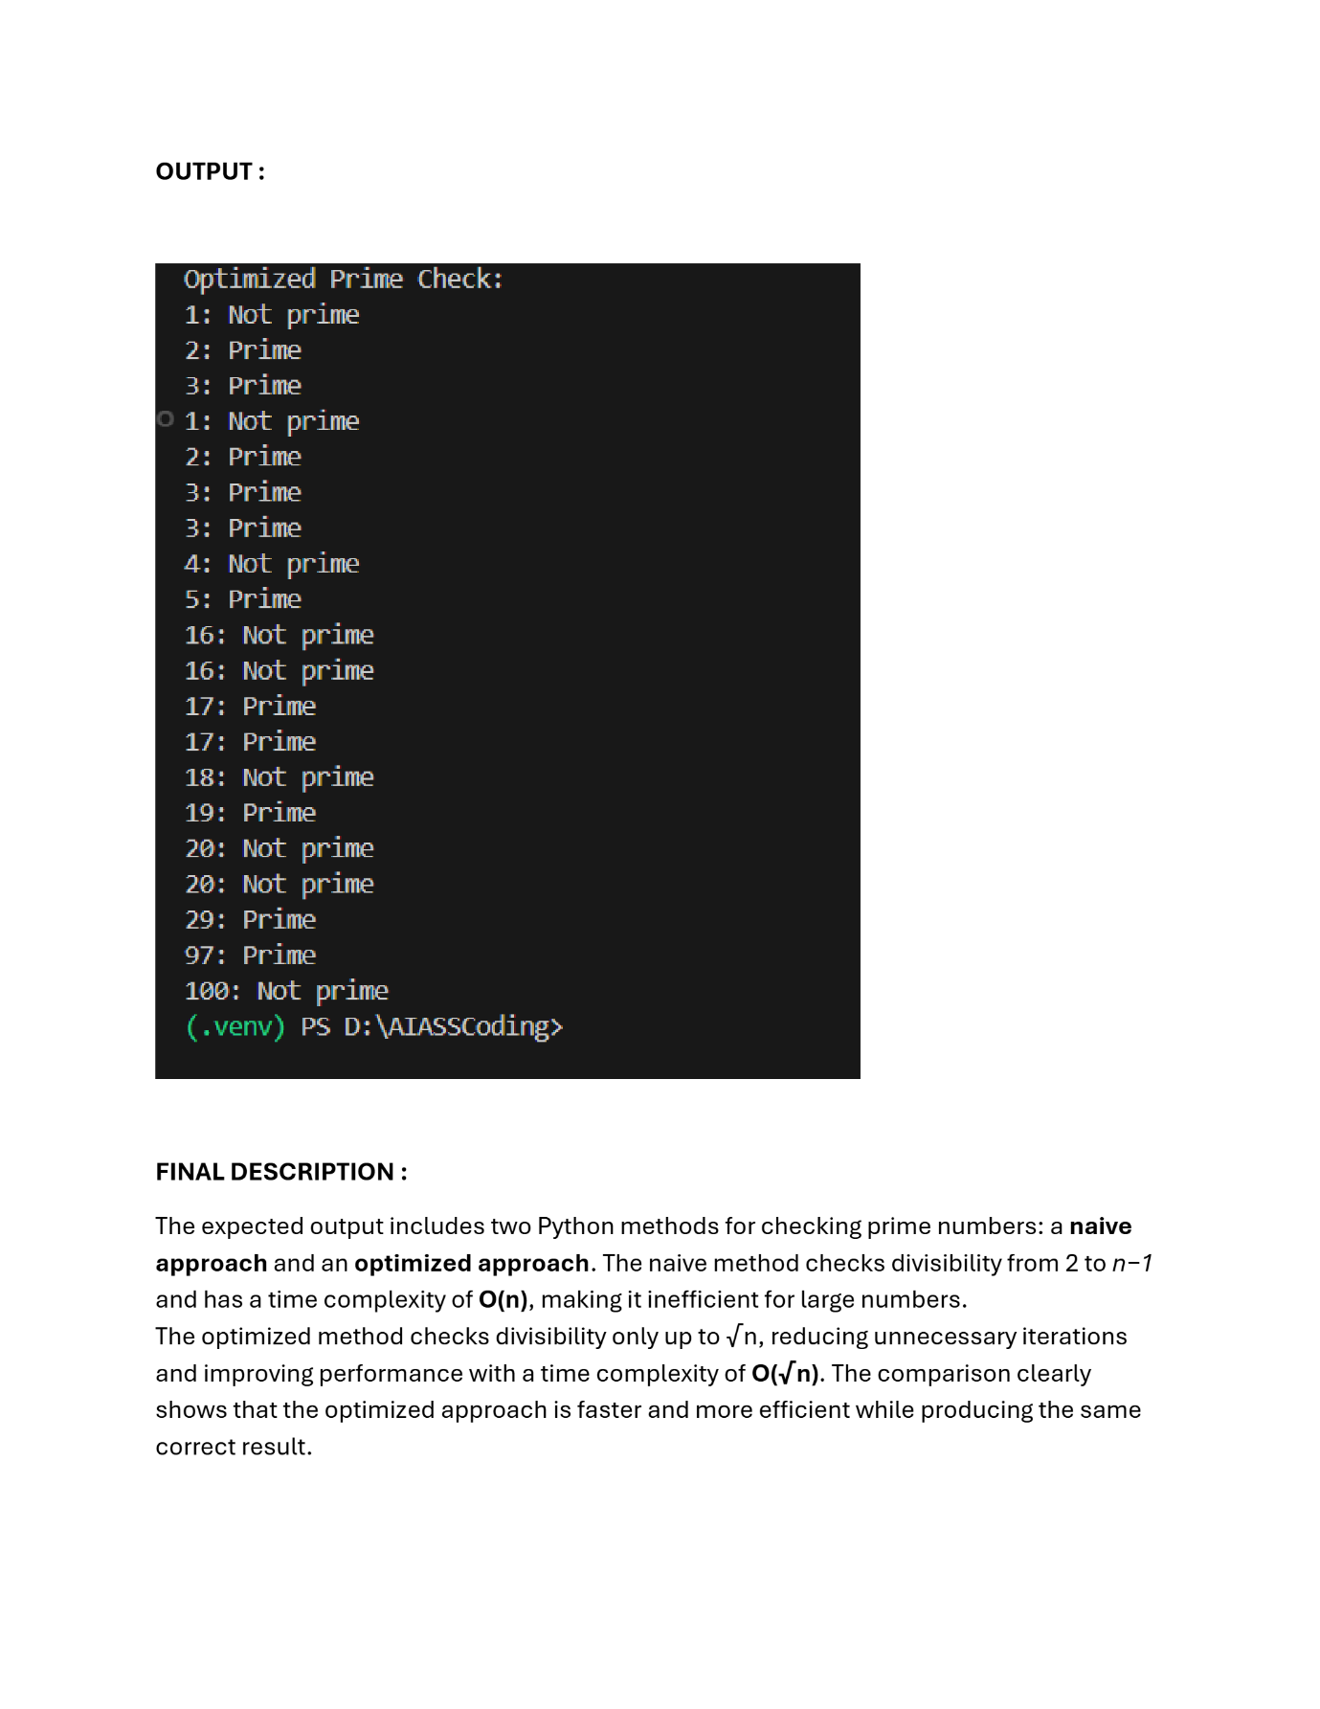

Task Description #2 (Transparency in Recursive Algorithms)
Objective: Use AI to generate a recursive function to calculate
Fibonacci numbers.
Instructions:
1. Ask AI to add clear comments explaining recursion.
2. Ask AI to explain base cases and recursive calls.
Expected Output:
• Well-commented recursive code.
• Clear explanation of how recursion works.
• Verification that explanation matches actual execution.
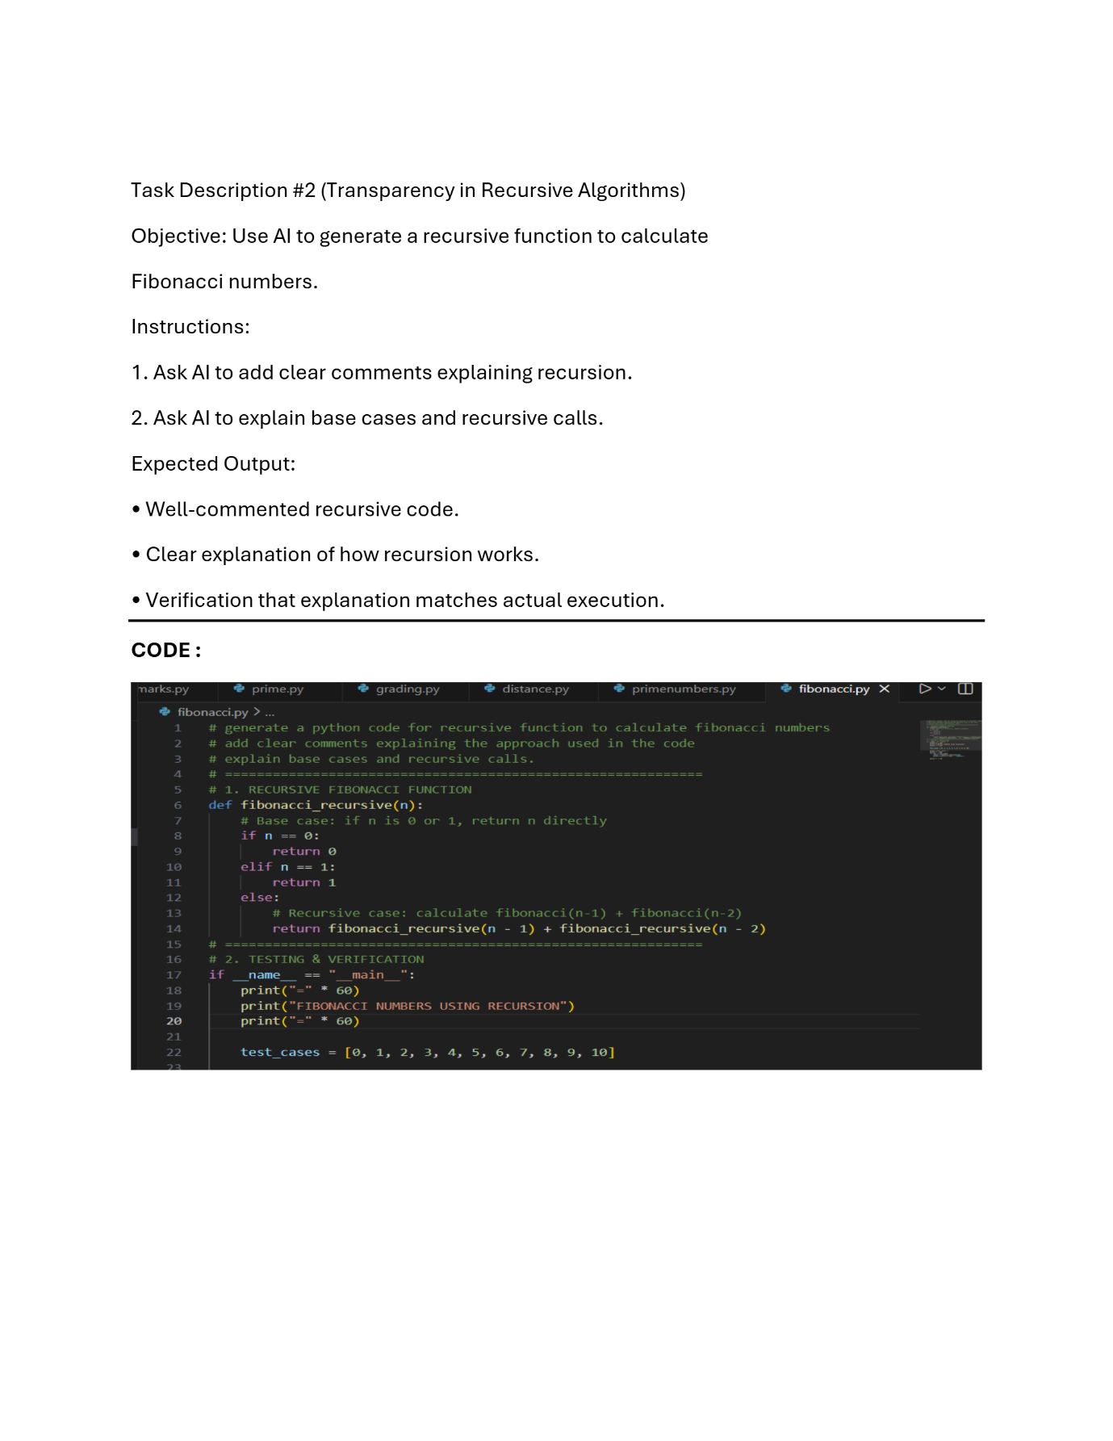
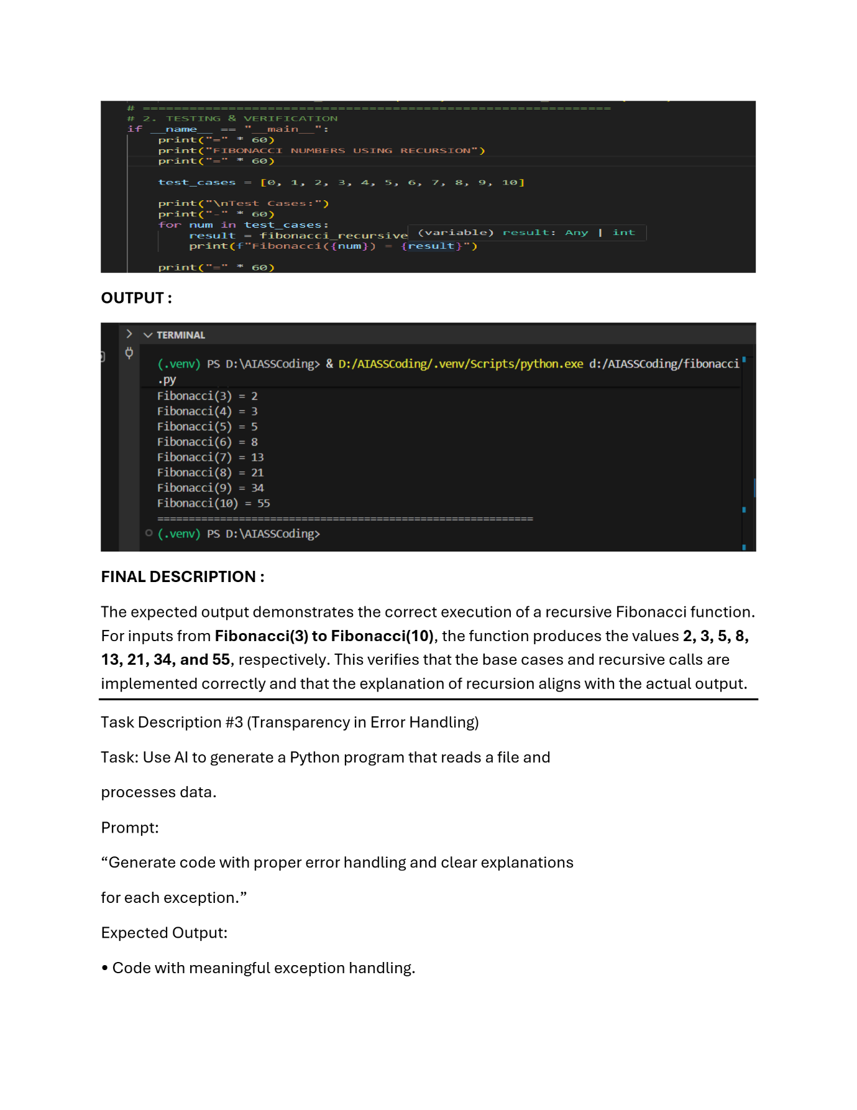

Task Description #3 (Transparency in Error Handling)
Task: Use AI to generate a Python program that reads a file and
processes data.
Prompt:
“Generate code with proper error handling and clear explanations
for each exception.”
Expected Output:
• Code with meaningful exception handling.
• Clear comments explaining each error scenario.
• Validation that explanations align with runtime behavior.
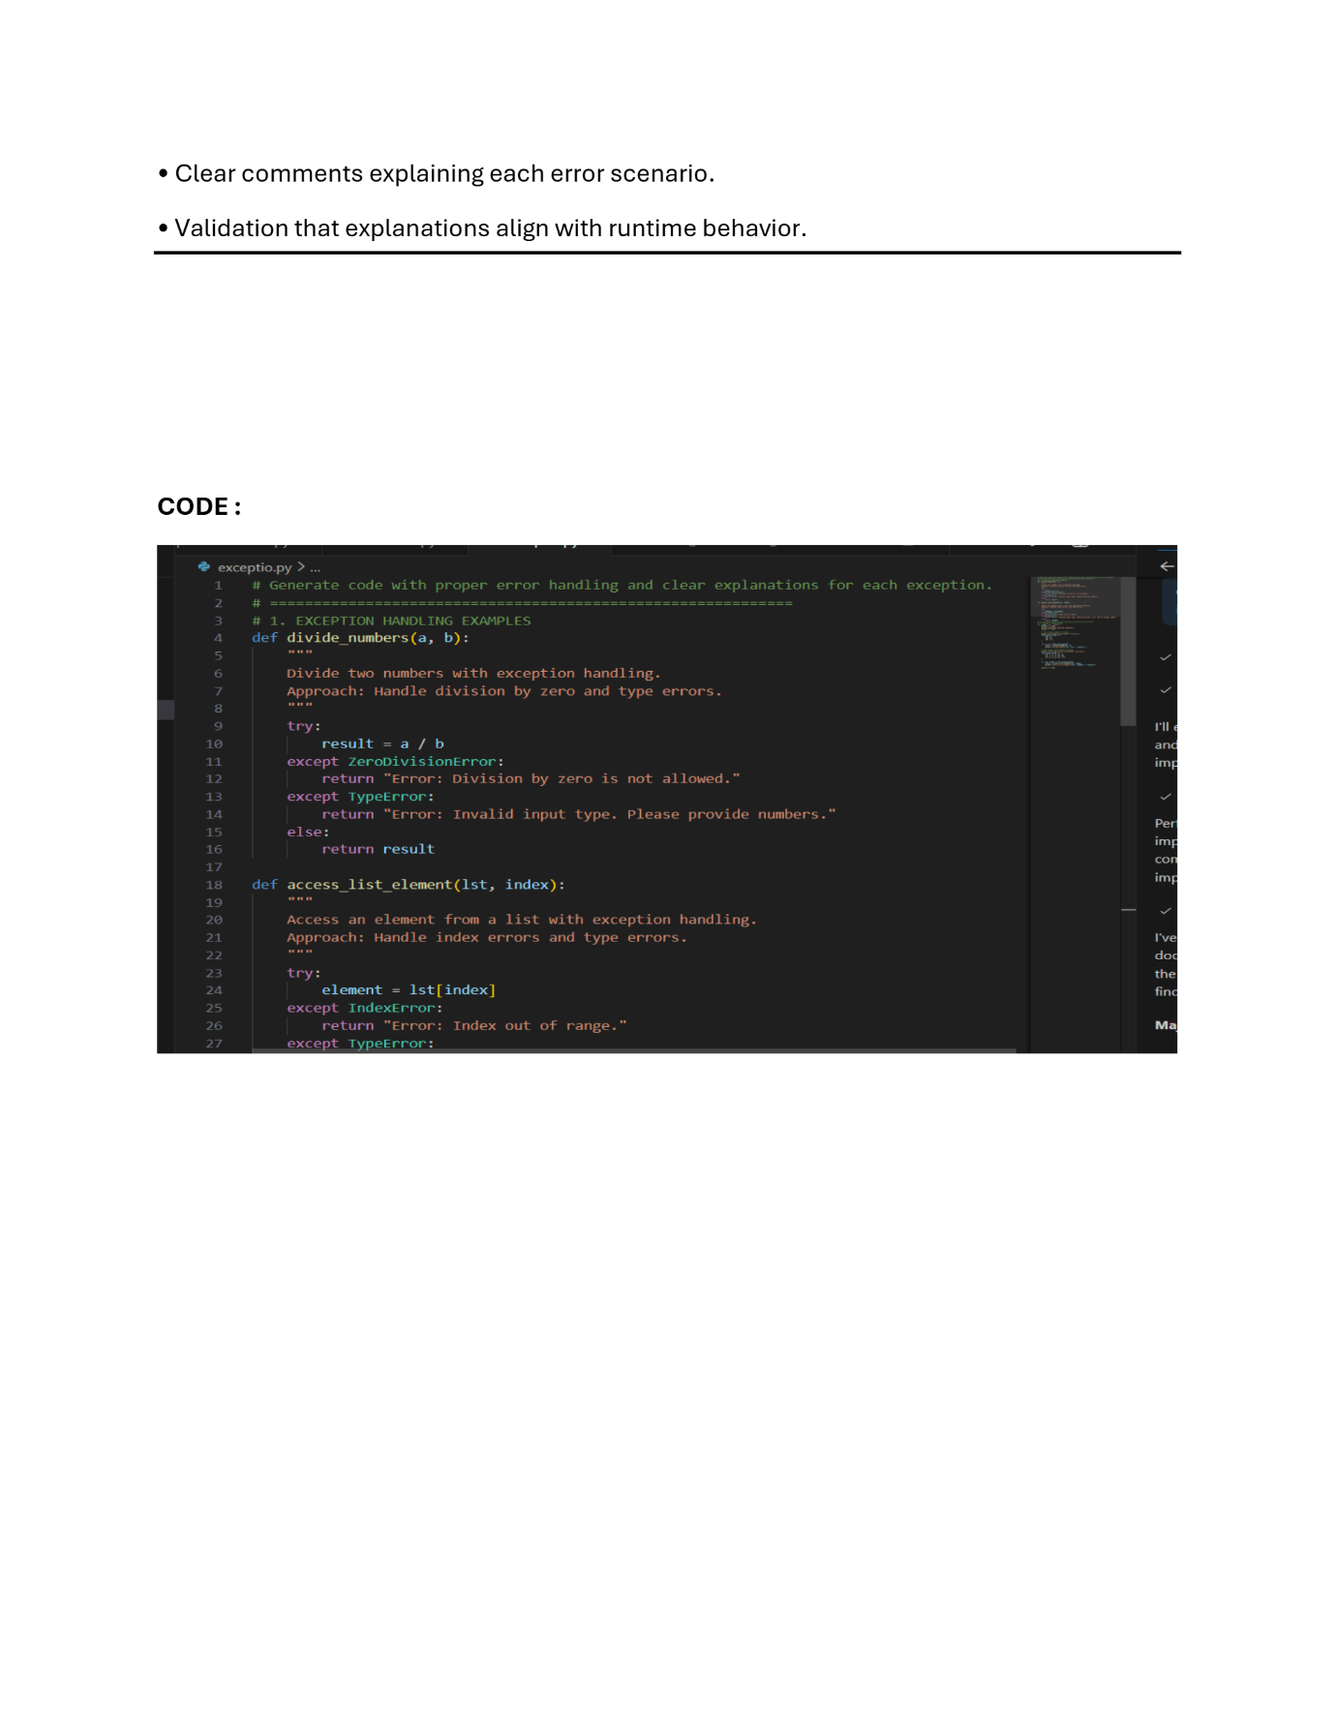
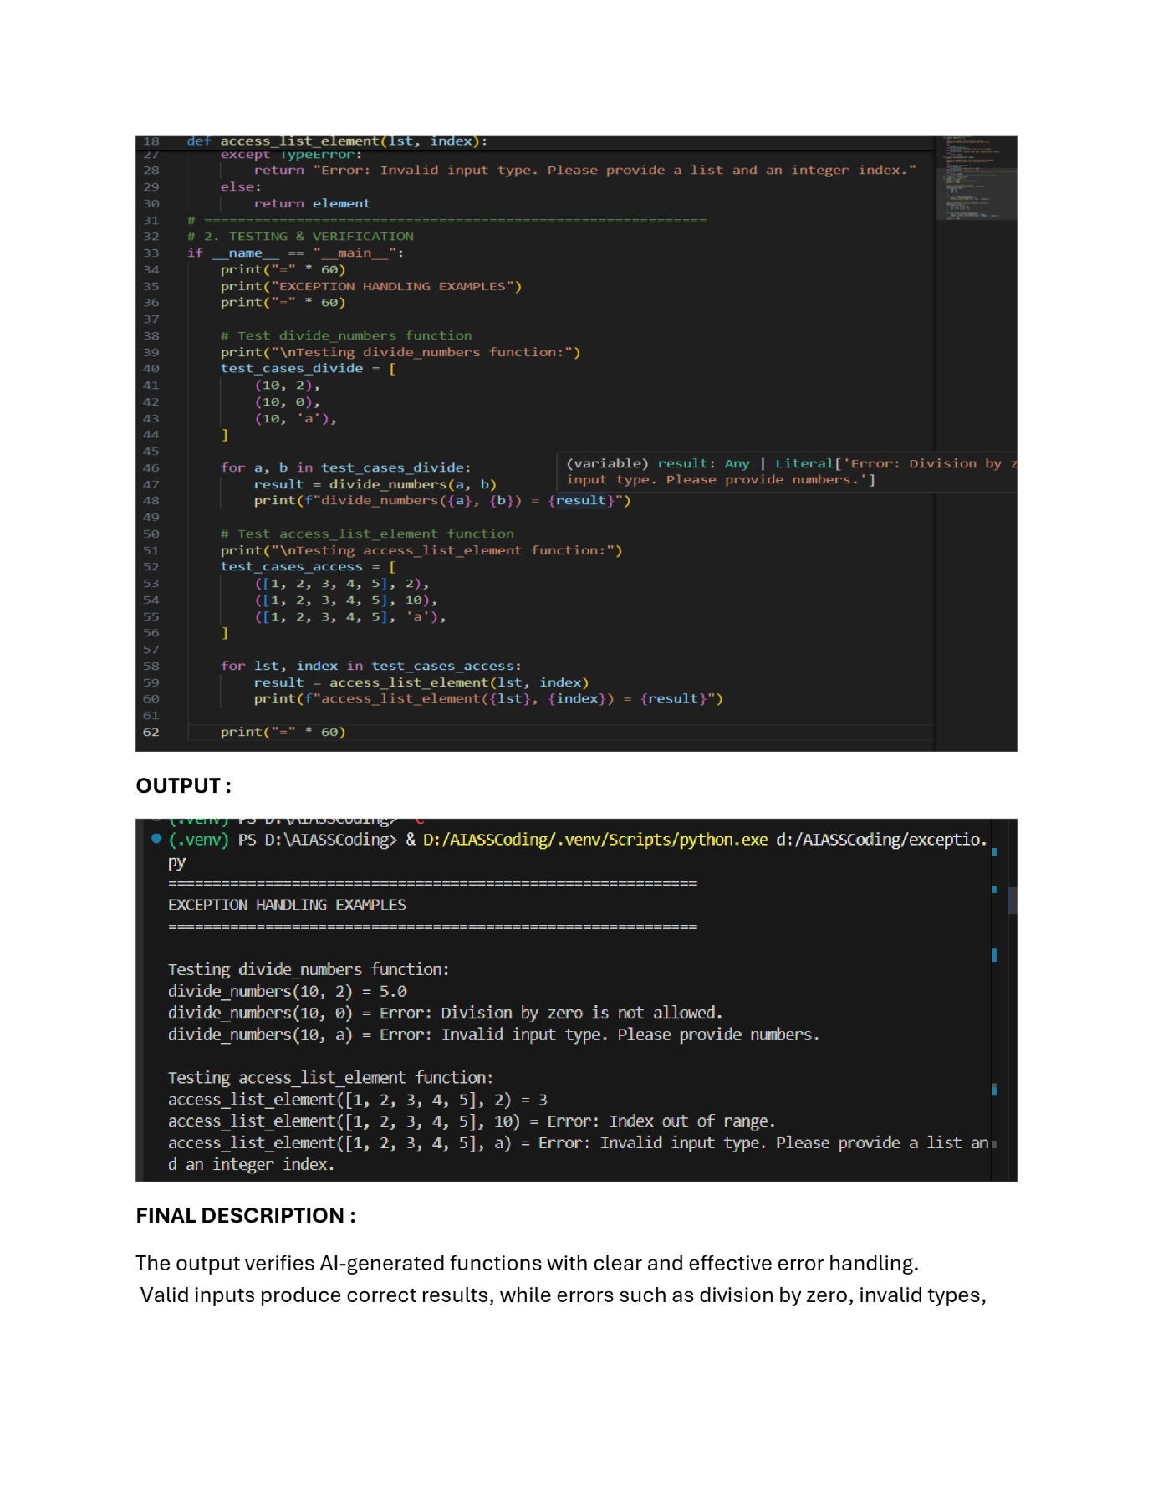

Task Description #4 (Security in User Authentication)
Task: Use an AI tool to generate a Python-based login system.
Analyze: Check whether the AI uses secure password handling
practices.
Expected Output:
- Identification of security flaws (plain-text passwords, weak
- validation).
- Revised version using password hashing and input validation.
- Short note on best practices for secure authentication.

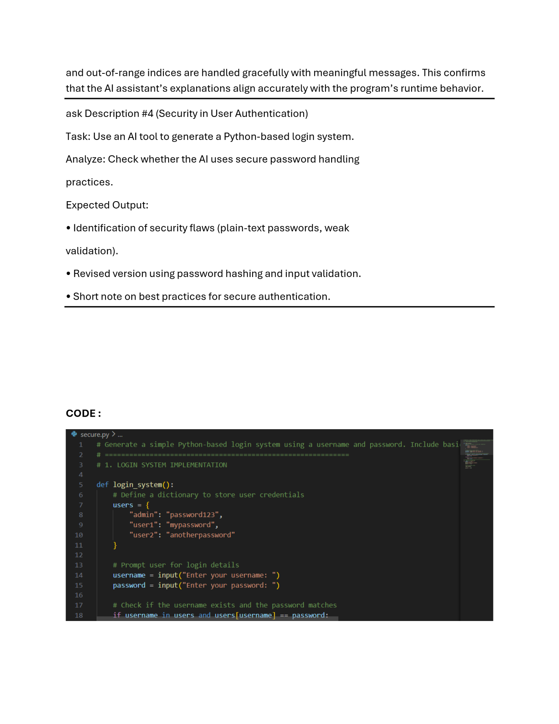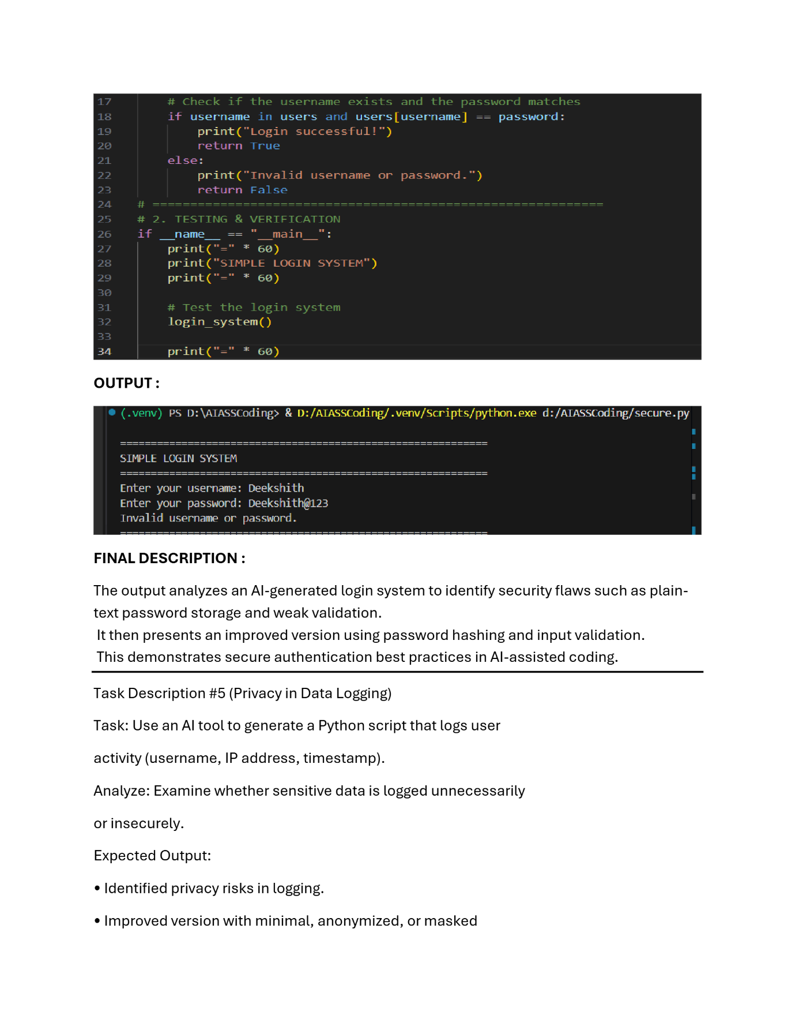

Task Description #5 (Privacy in Data Logging)
Task: Use an AI tool to generate a Python script that logs user
activity (username, IP address, timestamp).
Analyze: Examine whether sensitive data is logged unnecessarily
or insecurely.
Expected Output:
• Identified privacy risks in logging.
• Improved version with minimal, anonymized, or masked
logging.
• Explanation of privacy-aware logging principles.
